Sprint Report 2
  - Portfolio task 2/3/4
Unit code: EAT40005
Unit Name: Engineering Project A
Submission date: 19/05/2025

Student Name | Student Id | Statement of contribution to the report
Senupama Deshapriya | 104329709 | Senupama had a role in all parts of the Sprint 2 report including the Sprint Plan updates, Lessons Learned, and the Retrospective Summary. She also assisted to facilitate completion of team tasks on the Jira board and to help coordinate reporting on team progress during the sprint. Senupama supported the team in refining the client feedback log, formatting and compiling all team sections, as well as helping to coordinate online meetings.
Chrishelle Anthoneyz | 104067504 | Chrishelle was heavily involved in developing the Sprint Demonstration and Sprint Review sections, which included describing important animation development and logic-driven improvements that had been made since Sprint 1. She worked on formatting, proofreading and aligning content throughout the report. She supported the preparation of assets including screenshots, diagrams, and visuals about compost flow.
Haritha Perera | 104207449 | Haritha made contributions to documenting the animation features of the composting system, in particular lid and paddle motion. He established the structure for the section Key Features Demonstrated and prepared supporting visuals included in the report. Haritha was helpful when assisting with the breakdown of the Jira tasks, was useful with time estimations, and flagged deficiencies about the exit bottleneck related to export complexity.
Thenura Kuruppuarachchi | 103512993 | Thenura collaborated closely with me on the Sprint Retrospective and helped communicate the client feedback in the review section. He also was helpful with inputs related to most sections, including suggesting ways to improve fallback planning and made suggestions to try to enhance clarity. Thenura made contributions to Reflective Play by advising upon actions to start, stop and continue in future sprints.

Acknowledgment of Country
Each team member identifies the Traditional Owners of the land they lived on while completing this work.
- Senupama Damdini Deshapriya acknowledges the Wurundjeri Woi Wurrung people as the Traditional Owners of the land they lived on while completing this work in Melbourne, Victoria.
- Chrishelle Anthoneyz acknowledges the Wurundjeri Woi Wurrung people as the Traditional Owners of the land they lived on while completing this work in Melbourne, Victoria.
- Haritha Manuja Perera acknowledges the Wurundjeri Woi Wurrung people as the Traditional Owners of the land they lived on while completing this work in Melbourne, Victoria.
- Thenura Dulnath Kuruppuarachchi acknowledges the Wurundjeri Woi Wurrung people as the Traditional Owners of the land they lived on while completing this work in Melbourne, Victoria.

Sprint plan
For Sprint 2, our team focused on implementing animation, sensor integration, and visual enhancements to the SolidWorks model of the LIDA composting machine. The sprint aimed to address key feedback from the client, particularly the request to visually simulate the composting process and accurately place key internal components such as sensors, actuators, and airflow systems. This work supports the larger project goal of representing the physical LIDA composter through a 3D model embedded in a mobile application.
The Sprint 2 backlog was created in Jira with five main user stories and their corresponding subtasks, each assigned to team members with estimated story points. As per unit guidelines, each team member is expected to contribute approximately 10–12 hours per week, totalling around 30–36 hours per member over the three-week Sprint 2 period. This results in an estimated overall team workload of 120–144 hours for the sprint. During Sprint Planning, we used story points to estimate task complexity, effort, and time investment required for each subtask. Subtasks ranged from 2 to 6 story points depending on technical difficulty, time sensitivity, and level of collaboration needed.
The distribution of work was carefully planned to ensure equity:
- Senupama took the lead in animation syncing, sensor positioning, and documentation
- Chrishelle focused on SolidWorks animation (lids), visual labelling, and slide creation, report finalisation
- Haritha contributed to sensor integration, real-time logic design, and app alignment planning
- Thenura handled complex mechanical animations (paddle, gate), insulation modelling, and GitHub integration
Task progress was tracked in Jira with story point totals per person aligned to individual capacity. Additional unplanned client-requested tasks were picked up mid-sprint and integrated seamlessly, reflecting the team's flexibility and balanced workload allocation.
The screenshots below provide a visual breakdown of the sprint plan, including detailed subtask allocations and progress tracking for the sprint.
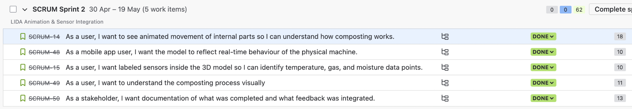
Fig 1. Backlog of sprint 2
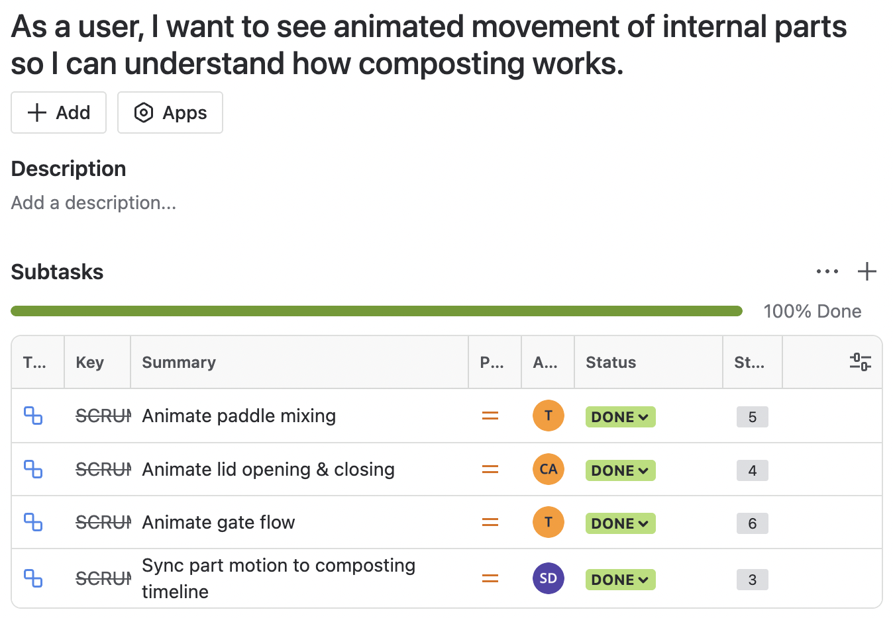
Fig 2. Subtasks linked to user story 1
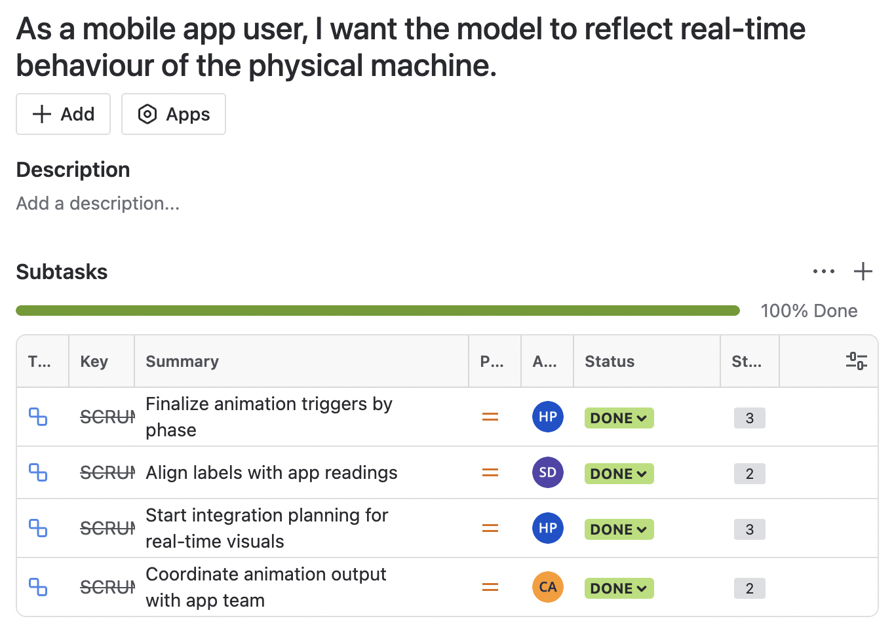
Fig 3. Subtasks linked to user story 2
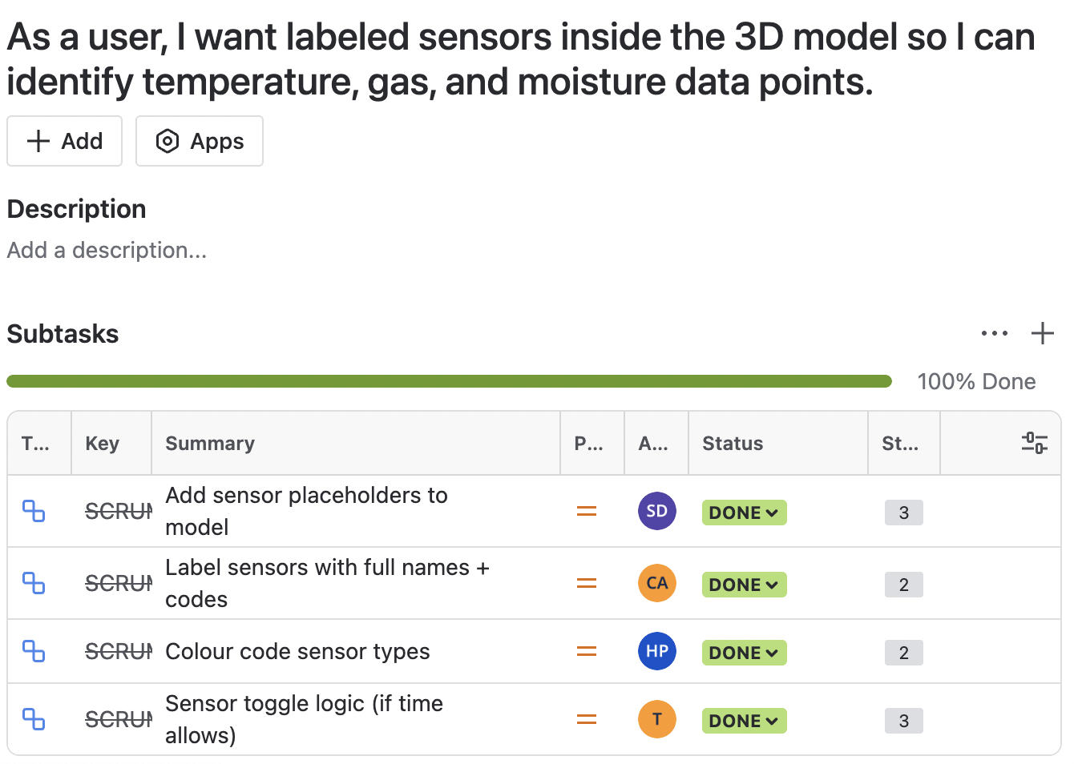
Fig 4. Subtasks linked to user story 3

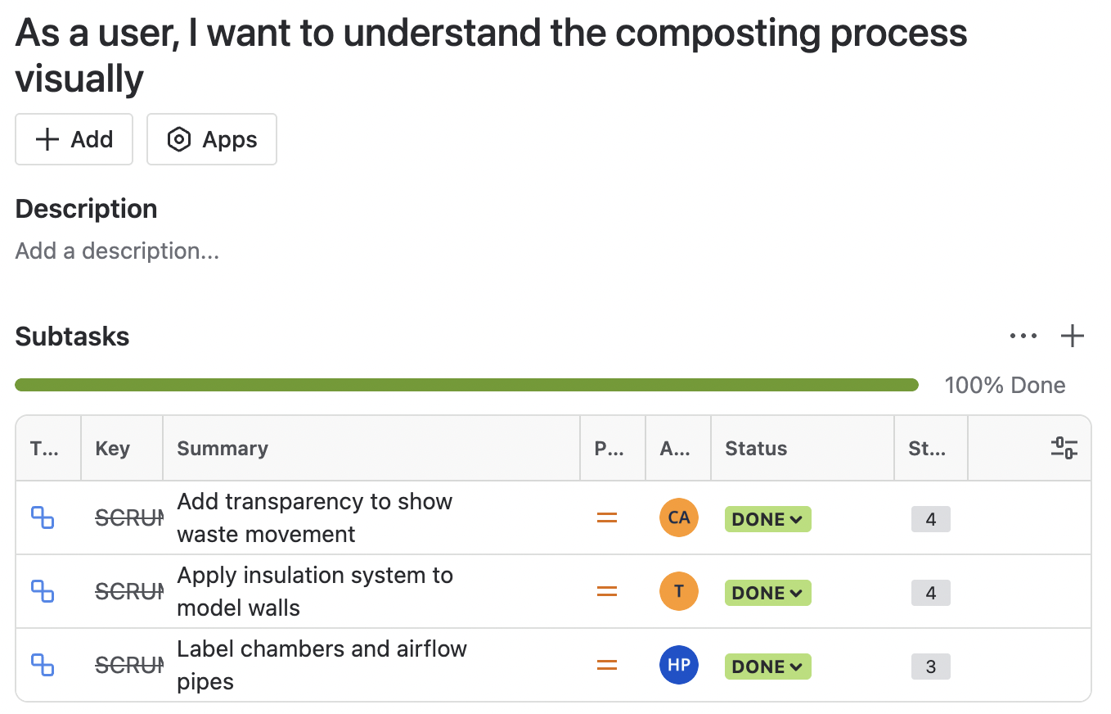
Fig 5. Subtasks linked to user story 4
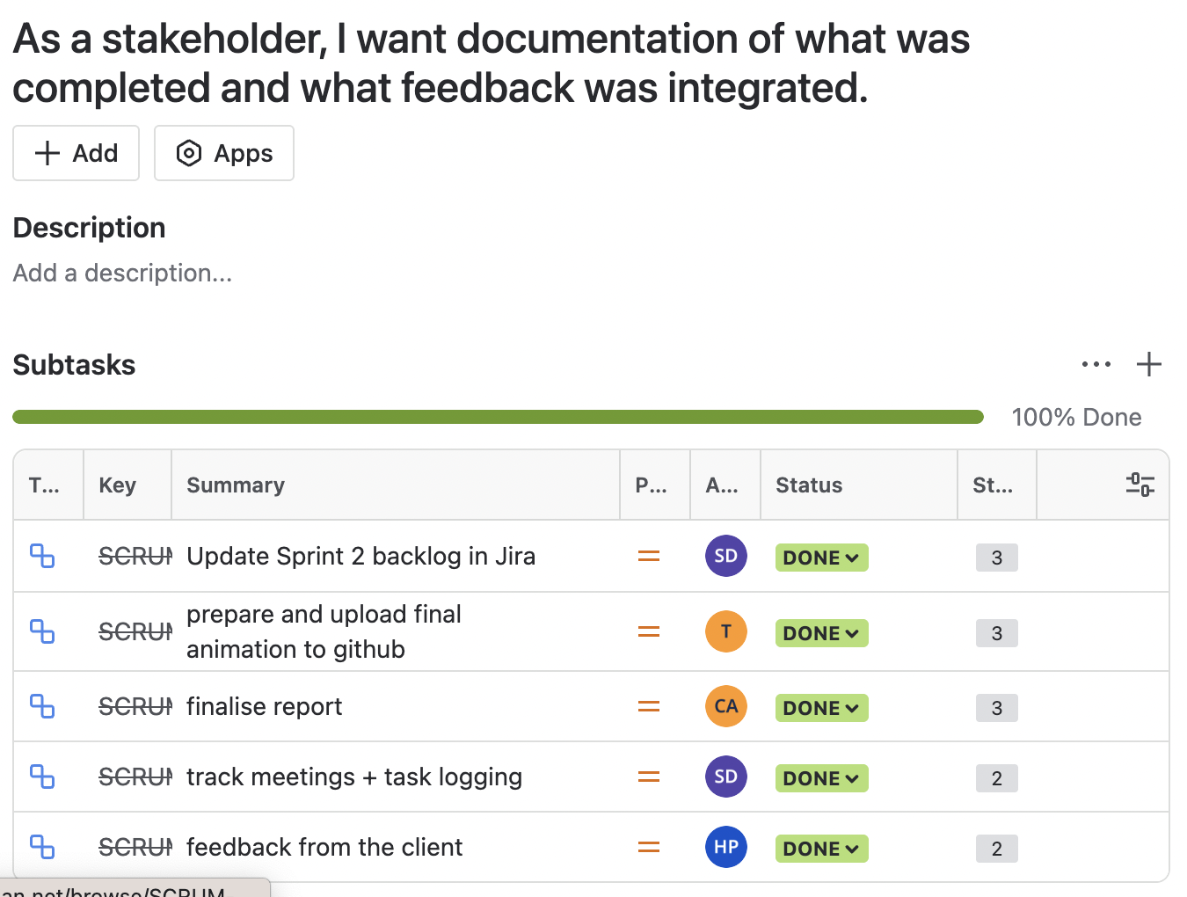
Fig 6. subtasks linked to user story 5

Sprint progress
During Sprint 2 (30 April – 19 May), the team successfully completed all tasks outlined in the initial backlog, including animation of composting mechanisms, integration of sensors, visual improvements to the SolidWorks model, and documentation. Specifically, the paddle movement, lid opening, and gate flow were animated and synced to the composting sequence. The team aligned model labels with the mobile app, planned for real-time visual integration, and collaborated with the app team on animation triggers. Sensor elements, including placeholders, proper labels, and colour-coded representations were added, along with initial logic for toggling sensor states. Visually, the composting process was enhanced by making chambers transparent, adding insulation inside model walls, and clearly labelling airflow systems. Documentation and delivery tasks were also completed, including the final animation export, Sprint 2 report, and client demo slides.
In addition to planned work, several tasks were added during the sprint in response to ongoing client feedback. These included restructuring the compost flow to clearly show waste movement from Active to Curing to Output chambers, flattening the top surface of the model, thickening lids to 2 cm, and redesigning sensors based on the client's references. Transparent wall elements were implemented across all phases as per the client’s request, and sensor wires were added for a more realistic look. Furthermore, the team initiated the process of simplifying the model for mobile app compatibility, ensuring the app version of the model remains lightweight and responsive. These enhancements were not part of the original backlog but were crucial to aligning the product with the client’s evolving expectations and were completed before the Sprint 2 demonstration.
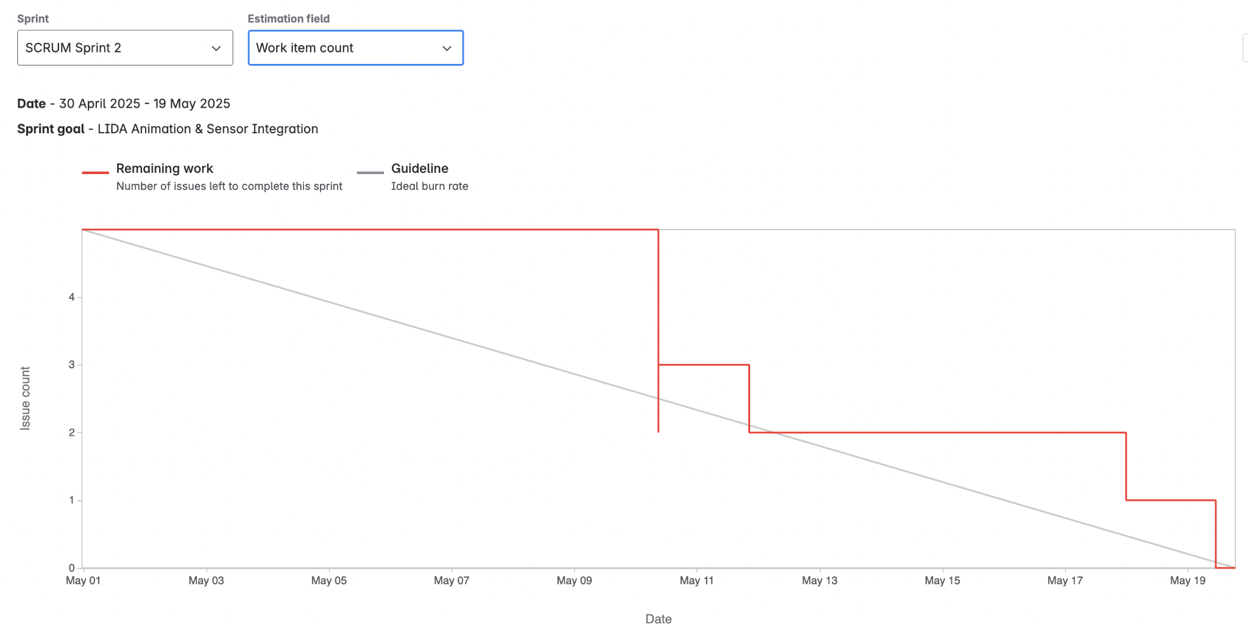
Fig 7. Sprint burndown chart of sprint 2
The burndown chart below tracks our team’s progress throughout Sprint 2. The visible spike in the issue count midway through the sprint reflects additional tasks added in response to client feedback received during ongoing discussions. These included hardware visualization enhancements, additional animations, and sensor logic improvements, which were not originally part of the sprint backlog but were successfully completed within the sprint timeline.

Team Member Contributions
- Senupama Deshapriya
Senupama played a central role in coordinating Sprint 2 activities and ensuring that the team remained aligned with both the sprint backlog and client expectations. She was responsible for developing the composting timeline logic that guided animation synchronization. This ensured that actions like paddle rotation, lid movement, and chamber transitions followed the real composting phases in sequence. She also placed sensor markers in the model, aligning them with logical positions based on temperature, moisture, and gas readings. Additionally, Senupama maintained the Jira board updating story points, closing completed tasks, and ensuring accurate tracking of team progress. She also documented both facilitator and client meetings and took the lead in writing and editing the Sprint 2 report, including the incorporation of Sprint 1 feedback and workload estimations. Her dual contributions in both technical modeling and documentation ensured the team’s outputs were both functionally correct and professionally presented.
- Chrishelle Anthoneyz
Chrishelle was primarily responsible for the animation of lid mechanisms and for creating visual outputs to represent compost flow. She ensured that the lid animations followed a logical actuator-based opening system and complemented the paddle and gate movements, enabling the team to build a coherent animation sequence. She also contributed to sensor representation by labelling sensor types (e.g., CH₄, CO₂, MC1) using scientific notation and ensuring that these labels were clear and consistent within the model. Furthermore, she led the creation of the Sprint 2 demonstration slide deck and collaborated closely on finalising the animation output for client presentation and app integration. Chrishelle’s work bridged the gap between model design and communication, ensuring both the functionality and clarity of visual demonstrations.
- Haritha Manuja Perera
Haritha took charge of planning the app-model alignment, focusing on ensuring that the animated phases of the composter could eventually reflect real-time sensor input. He defined the logic for animation triggers, coordinated feedback from the client about phase transitions, and translated this into subtask development. He also managed structural improvements to the model, including airflow piping and chamber labelling. Haritha color-coded the sensor types in the model, making it easier to distinguish between temperature, gas, moisture, and motion sensors. In addition, he helped revise the Sprint 2 report, tracked internal meetings, and contributed to integrating late stage feedback. His contributions strengthened the realism and functional mapping of the model to the composting process, while also ensuring task planning stayed on track.
- Thenura Kuruppuarachchi
Thenura focused heavily on technical development and SolidWorks animation. He built the bidirectional paddle animation (rotating 2 minutes in each direction), gate transitions between chambers, and implemented toggle logic that mimicked sensor-driven actuation. His animations were crucial to visually communicating the composting phases as per the client’s instructional model. Thenura also reworked the structural model based on client requests, thickening lids to 2 cm, adding insulation layers, and separating parts to simplify animation workflows. He collaborated with Chrishelle on final rendering and uploaded the compiled animation to GitHub for team access and integration testing. His detailed SolidWorks contributions allowed the team to present a highly accurate and visually rich 3D model during the Sprint 2 demonstration.

Sprint Demonstration
The Sprint 2 demonstration was held in Room AD324, Swinburne University of Technology, on Friday, May 16, 2025, from 4:30 to 6:00 p.m. The meeting was attended by the client, Mr. Alex Jaimes Castillo, both hardware development teams in charge of the physical modeling of the LIDA composter, and all members of our team, Senupama Deshapriya, Thenura Kuruppuarachchi, Chrishelle Anthoneyz, and Haritha Manuja Perera.
This demonstration showed considerable progress made during Sprint 2, with a strong focus on creating animation in SolidWorks and conceptual integration with the future mobile app. The goal was to simulate the real-life working of the LIDA composter, its lid functionality, paddle mixing mechanism, waste movement between chambers, and final composition output while illustrating sensor-triggered logic and structural enhancements based on previous client feedback.
Our software team provided several key enhancements in the Sprint 2 demo, focusing on advanced animation logic, internal structure accuracy, and future integration potential with the mobile app. Some enhancements that were highlighted include:
- Realistic Lid and Gate Animations
Individual lids were made to open individually using actuator logic to simulate actual safety functions. Transfer gates also moved according to composting phase logic, providing real switching between chambers within the composting cycle.
- Improved Paddle Rotation
Paddles were programmed to spin alternately and inversely. This was a real replication of compost mixing operations in active and curing phases and addressed one of the highest-priority feedback items in Sprint 1.
- Sensor-Based Logic Integration
Logic demonstration was a reflection of real environmental reaction. For example, paddles and air pumps were shown to switch on automatically if temperature was above 70°C. The system visually shut down once the parameters stabilized. Future development was outlined to mimic logic for gas (CO₂, CH₄) and moisture sensors.
- Internal Structure Improvements
- Transparent panels were used in a move to improve internal visibility.
- Placeholder compost blocks were used in a bid to mimic compost load and stage.

- Labelling and Simplification of Components
Internal components like sensors and actuators were tagged with simple tags (e.g., T1 for Temperature Sensor, M1 for Motor) for interpretation simplicity and uniformity in application integration.
The updated 3D model is shown below, with chamber views and component locations emphasized:
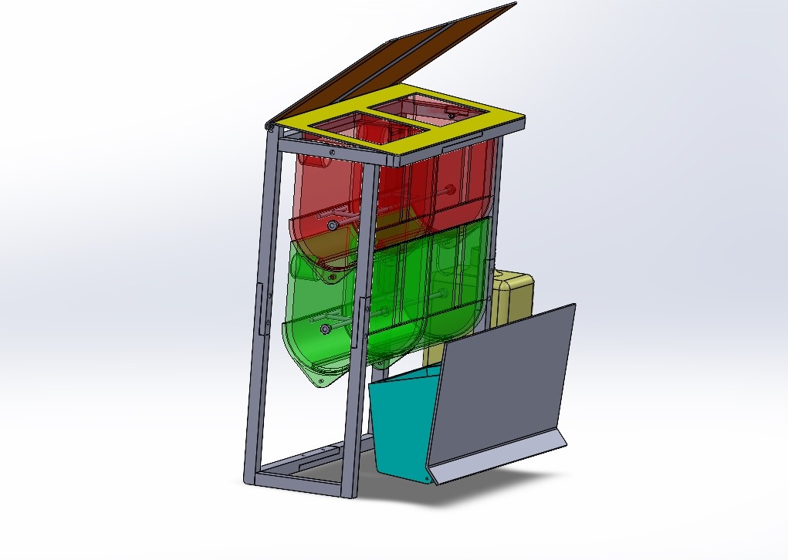
Figure 8: LIDA composting model with active, curing, and completed compost tank with top lid.
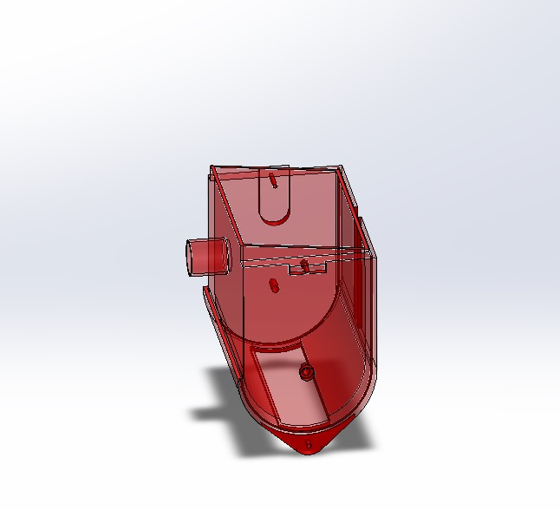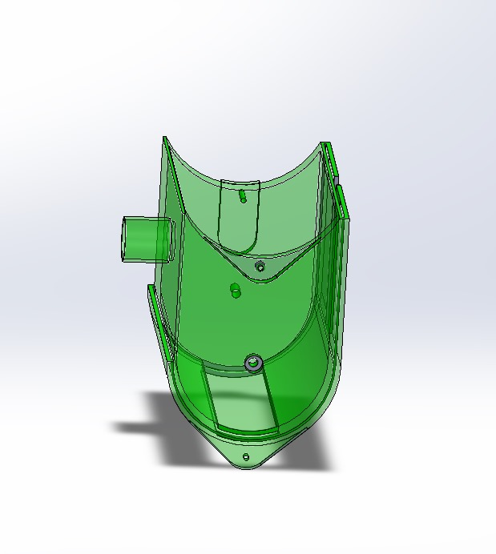
Figure 9 & 10: Active Phase Chamber (red), for initial decomposition of waste, with air passage port. Curing Phase Chamber (green), with increased curvature and outlet design for improved compost flow.

The client provided feedback on the new model and animations submitted in Sprint 2 that was positive and constructive. Some of the points mentioned are:
- Positive Observations
- Clear animation sequence with logical phase transitions.
- Improved structural realism and improved labeling of compartments and components.
- The visual improvements were acceptable and consistent with composting flow.
- Recommendations for Further Improvement
- Paddle Speed: Slowing the speed is more realistic.
- Timing strengths – Animations (e.g. opening the lid) need to wait a short amount of time (2–3 seconds) to be realistic.
- Placeholder Material More realistic we need that instead of a static blocky compost.
- Lid Improvements: Lids should be 2 cm thick and flat lying, flush to the top surface.
- Pipe Inclusion: Suggested the inclusion of 3 cm diameter pipes for ventilation and the draining of water, as well as visual markers for motor and tube placement.
In general, the demo was successful at showing tangible progress towards project goals. The client was pleased with the updated animation logic and system structure, ensuring the project was going in the right direction for Sprint 3.

Sprint review (Critical review of the product)
Sprint 2 Demo Overview of presented demonstration
Sprint 2 review meeting, which was conducted on Friday, 16th May 2025, 4:30 PM – 6:00 PM at Swinburne University of Technology, in Room AD324, demonstrated the transition of the team from static modelling to dynamic simulation. The demonstration involved bringing together hardware teams and the client to evaluate newly added features and improvements.
This phase was a strategic shift toward advanced animation development within SolidWorks, emulating actuator movements, composting mixing dynamics, and temperature-based automation. Along with this, preliminary integration planning into mobile apps was added, based on real-world-similar user input and system responses with sensor inputs. The presentation not only presented advancements but also elicited crucial inputs for the enhancement of the functionality and usability of the system.

Key Features Shown
The following features were effectively shown:
- Composting Process Animation:
The full composting cycle - active phase, curing phase, and final compost produced - was shown with animated transitions of lids, gates, and internal paddles.
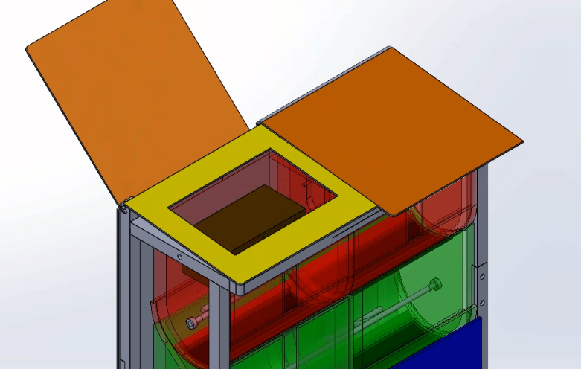
Figure 11: Lid Mechanism Configuration
- Actuator-Controlled Lid and Gate Motion:
The lids were opened independently in accordance with their respective logic based control sequence. Gates were animated to simulate an operational safety mechanism for transferring compost.
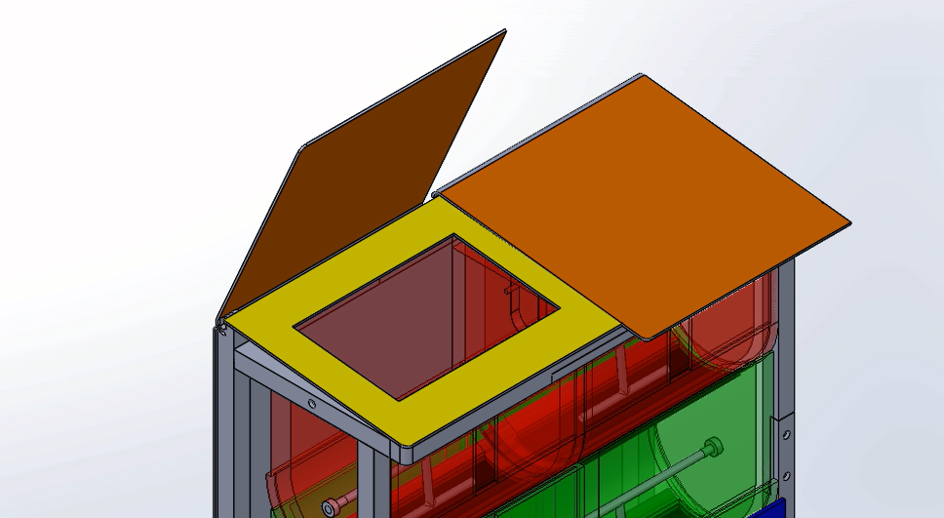
Figure 12: Independent Lid and Gate Logic

- Paddle Motion was Driven in Opposite and Aligned Direction:
The paddles were animated to demonstrate opposite and shifting rotation to demonstrate reasonably accurate mixing dynamics of mixed compost material.
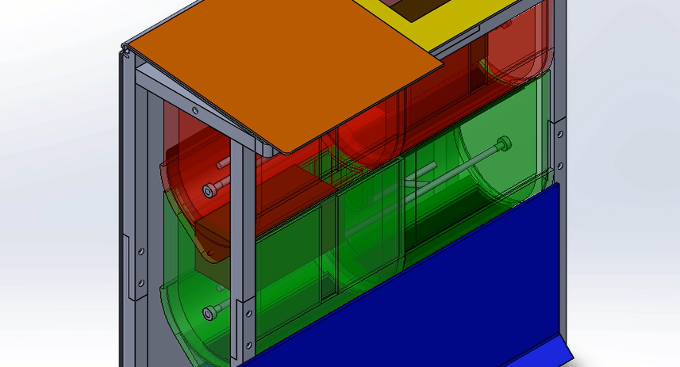
Figure 13: Paddle Motion Simulation
- Sensor Logic Animation Logic:
The paddles along with airflow systems animated sequencing sequences to include activation of turning on when compost material has reached greater than 70°C, and would revert to off status when conditions were within parameters. A marker/placeholder sensor component such as T1, M1, G1 changes were included to ensure relative clarity for future integration.
- Improved Transparency and Internal Layouts:
Visible components animated the interior design, conveyor compost material, and layout flow conventions of the display to allow 'seeing comprehending' presentation to an observational subject.
- Assessed Simplified labeling for App-Layer Integration:
Markers were simplified with basic tags when identifying, imagining the opportunities for transitional visualization to integration with an app would require simplification.

Client Feedback
Our Client gave a positive feedback about the revised animation and system flow with the following notes/provided feedback:
- Strengths Recognized:
- High clarity in the logical flow of stages of composting.
- Structural segmentation and color-coded chambers assisted with comprehension.
- Visual quality and behavior of compartments was accurately represented.
- Opportunities for Improvement:
- Paddle speed increased to slower and more realistic speed.
- Lid thickness increased to 2 cm to represent insulation and realism.
- Replacing static blocks of compost with dynamically simulated organic matter.
- Achieve realistic and intuitive delays for actuators in animations, and sequencing.
- Include 3 cm piping for airflow and moisture control.
- Expect to have animated pictures that will be triggered by sensors on the mobile application.
Progress Assessment and Reflection
Sprint 2 represented a significant increase in technical difficulty and animation depth when compared to Sprint 1. The team accomplished the following:
- Complete animations of lid, gate, and paddle movements with conditional logic triggers.
- Improve realism of internal components and used transparency and placeholder visual compost to simulate compost matter behaviour and materials, and assigned colour-coding from blocks.
- Incorporated basic logic rules to simulate temperature controlled behaviour in the existing compositions.
- Improve segmentation of the model, and included testing for .GLB/.FBX export and potential deployment to the LIDA app.

Challenges and resolutions
Challenge | Description | Resolution
Model Complexity | Exporting SolidWorks files to the app caused interpreting errors and format incompatibility. | Model was modularised and simplified; unnecessary layers were removed.
Time Constraints | Mobile integration and compost visual detail were organised. | These tasks were scheduled for Sprint 3 with clear milestones.
Sensor Coordination | Misalignment with hardware assumptions caused label and structure errors. | Regular syncing with the hardware team was reintroduced mid-sprint.
The team had a strong commitment to adopting the feedback and producing animations that were technically accurate. The changes made to all the animations created both functional and learning value to the client as it improved understanding. The collaboration, planning, and modular design had improved, and the revisions used client feedback effectively. But the extended time taken to include the app versions to the recommended animations showed that the team underestimated development times and did not properly buffer, as we had planned for some time to happen according to the planning sprint.

Retrospect (Critical review of the process)
Overview
After completing Sprint 2, we held a retrospective meeting to reflect on the collaborative aspects of our work, considering the ongoing themes we faced, and determine major opportunities to improve based on our deliverables throughout the sprint.
Meeting Details
Date | 17th May 2025 (Saturday)
Time and Venue | 5:30 PM
Attendees | Chrishelle Anthoneyz, Haritha Perera, Thenura Kuruppuarachchi, Senupama Deshapriya

Retrospective
Start Doing | Stop Doing | Keep Doing
Listing SolidWorks export errors and doing early device testing | Waiting until the client demonstrates to confirm visual/structural requirements. | Having formally structured internal weekly meetings
Setting of fallback animation software such as Blender or Fusion 360 | Assuming exports are mobile compatible without testing | Having coordinated sync meetings with other hardware teams
Weekly client alignment meetings as checkpoints for validation | Committing way more than you should without accounting for delay from file conversion/export. | Using ethical safety logic to command the motor control with the sensor feedback.
Creating story points using checklists especially for animation and app | Estimating animation tasks based on an average story point. | Keeping Jira Boards live and assigning ownership per feature or subsystem.
Rotating model for the role of animation QA, export testing and documentation | Only relying on one person to complete all export/model testing. | Feedback logs and requirement sheets updated weekly would capture those inputs.
Action Items for Upcoming Sprints
- Find and test an alternative (animation tool) platform to meet back up against whenever there is an issue with exporting from SolidWorks (e.g., Blender).
- Use point’s estimate of story point calculation with complex tasks (animations, logic simulations) by explaining the task in detail.
- Create mobile friendly lightweight modular versions of 3D model.
- Finalize sensor/motor placement diagrams and pipe routing to help the team get more internal alignment on the installation.
- Create a visual Q&A checklist (lid motion, paddle timing, etc.) for all animations.
- Build in time delays (~15%) in our planning for technical uncertainty.
- Continue to use Microsoft Teams and Jira to keep accountability for communication.
- Document & develop any prototyping that can be done for logic overlay in the app-side animations for Sprint 3.

Lessons learned (Critical review of SPRINT one experience and future plan)
1. Importance of Realistic Motion Simulations
The whole Sprint 2, the team realized that naturalistic motion simulation (i.e., bidirectional paddle movement and natural opening rates of lids) played a very important role in user understanding and client perception. The feedback revealed how fast or repetitive animations decrease the credibility of the model, especially for mobile demonstrational purposes.
2. Sensor Logic Adds Realistic Depth
Inclusion of trigger-based logic (e.g., activating paddles and airflow when temperature crosses 70°C) helped us in emulating composting conditions more precisely. This helped in making us appreciate the significance of combining hardware logic and software animation in presenting operational intelligence in an effective manner.
3. Client Feedback Must Be Revisited and Reconfirmed
The sprint taught us even functionalities already debated (e.g., sealing lids or pip placements) needed to be re-confirmed since assumptions in most cases ended in implementation incompleteness. We started documenting feedback more officially and checking off completed requests explicitly.
4. Accuracy in Simplified Labeling is Critical for Mobile Integration
Basic tag usage (e.g., T1, M1, G1) became essential in activating the mobilization of the SolidWorks model. Overly-detailed objects like full pipe geometry or wire meshes were lagging export to the mobile which encouraged us to reconsider our strategy of modeling for the sake of clarity over complexity.
5. Animation Exports Have Technical Constraints
Attempting to export animated SolidWorks models for use in other applications resulted in interactivity and real-time responsiveness problems. We found that animations had to be pre-rendered or decomposed into sequences and that enabling transparency or motion in the application was technologically limited.
6. Ethical Feedback Loops Improve Safety Design
One of the greatest ethical innovations was the implementation of motion sensors to hinder motor functions when opening lids. It was a reflection of the need for safety of users in actual products and showed us how to marry functional animation and operational safety guidelines.

Practical and Feasible Future Suggestions:
Area | Recommendation | How it will be implemented
Cross-Team Syncing | More consistent collaboration with hardware teams for animation references | Weekly check-ins and shared model access in cloud drive
Client Feedback Loop | Confirm requests after each demo with visual checklist | Use a feedback tracking sheet and verify during weekly meetings
Animation Refinement | Fine-tune lid/paddle animation speeds for realism | Use timer-based control logic and adjust frame rates accordingly
Mobile Compatibility | Create low-polygon, lightweight models without internal components | Export model layers separately and annotate only what’s necessary
Visual Labelling | Finalise internal tags for sensor locations and animation triggers | Label each sensor element visibly (e.g., T1, MC1, CH4)
App Integration Prep | Modularise animated sequences for step-based playback in mobile app | Use separate animation files and simplified video transitions
Future Plans for Sprint 3:
- Include logic overlay for composting system simulation in real-time.
- Generate lightweight mobile exports of 3D models.
- Refine fallback planning and modular animation sets to increase flexibility.
- Create a video walkthrough (1 minute) of the whole compost process.
- Mobile platforms file performance needs to be tested and confirmed for real-time demo.

